**EXPERIMENT 1**

**INTRODUCTION TO KL-300 DIGITAL TRAINER**

**Objective:**

To become familiar with KL-300 Digital Trainer.

**Theory:**

The KL-300 Digital Logic Lab is a comprehensive and self-contained system suitable for anyone engaged in digital logic experiments. All the necessary equipment for digital logic experiments such as power supply, signal generator, switches and displays are installed on the main unit. The 13 modules cover a large variety of essential topics for digital logic. It is a time and cost saver for both students and engineers interested in developing and testing circuit prototypes.

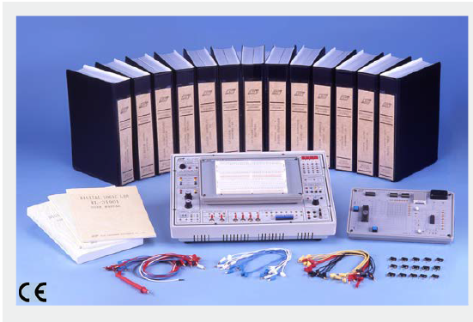

**Features:**

* Suitable for combination logic, sequential logic and microprocessor circuits design and experiments.
* Ideal tool for learning the basics of digital logic circuits.
* Comprehensive power, signal supply and testing devices for convenient experiments.
* Experiments are expandable and flexible with universal breadboard.
* Capable of processing TTL, CMOS, NMOS, PMOS and ECL circuits.
* All supply units are equipped with overload protection for safety purpose.
* All modules equipped with 8-bit DIP switch for fault Simulations.
* Individual keeping cases for all modules for easy storing and carrying.
* All signal generators have independent and simultaneous TTL and CMOS level output terminal.

**Specifications:**

**Main Unit (KL-31001)**

**1. Dual DC Power Supply**

(1) Voltage range: +5V, 1.5A; -5V, 0.3A; ±12V, 0.3A

(2) With output overload protection

**2. Adjustable DC Power Supply**

(1) Voltage range: +1.5V~+15V

(2) Maximum current output: 0.5A

(3) With output overload protection

**3. Standard Frequency**

(1) Frequency: 1MHz, 60Hz, 1Hz

(2) Accuracy: ±0.01% (1MHz)

(3) Fan out: 10 TTL load

**4. Clock Signal Generator**

(1) Frequency: 1Hz-1MHz (6 ranges)

a. 1Hz ~ 10Hz d. 1KHz ~ 10KHz

b. 10Hz ~ 100Hz e. 10KHz ~ 100KHz

c. 100Hz ~ 1KHz f . 100 KHz ~ 1MHz

(2) Fan out: 10 TTL load

**5. Data Switch**

(1) 8-bit DIP switch x 2, 16-bit TTL level output

(2) Toggle switch x 4, each with DEBOUNCE circuit

(3) Fan out: 10 TTL load

**6. Pulser Switch**

(1) 2 sets of independent control output

(2) Each set with Q, Q output, pulse width > 5ms

(3) Each set of switch with DEBOUNCE circuit

(4) Fan out: 10 TTL load

**7. Line Signal Generator**

(1) Frequency: 50 / 60Hz

(2) Output voltage: 6Vrms

(3) With overload protection

**8. Thumbwheel Switch**

2-digit, BCD code output and common point input

**9. Logic Indicator**

(1) 16 sets of independent LED indicates high and low Logic state

(2) Input Impedance: ≥ 100KΩ

**10. Digital Displays**

(1) 4 sets of independent 7-segment LED display

(2) With BCD, 7-segment decoder / driver and DP input

(3) Input with 8-4-2-1 code

**11. Logic Probe**

(1) TTL and CMOS level

(2) 5mm LED displays

(3) "Lo" and "Hi" LED display low and high logic state respectively

**12. Speaker**

One 8Ω, 0.25W speaker with driver circuit

**13. Breadboard Modules (AC-90001)**

1680 tie-point breadboard on top panel can be easily put into and taken off.

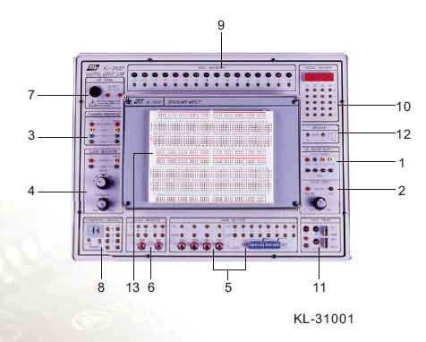

**Experiment Modules:**

* All 13 modules are equipped with an 8-bit DIP switch for fault simulation. Users learn how to solve various problems by setting the DIP switch to different positions.
* Solutions for all fault tests are listed in the experiment manual for user's reference.
* 2mm plugs and sockets are used throughout the main unit and all modules.
* Comprehensive experiment manual and instructor's manual.
* Module dimension: 255 x 165 x 30 mm.
* Connection plugs are used on the modules to prevent accidental damages.
* Individual keeping case for each module.

**List of Modules:**

1. KL-33001 Basic Logic Gates Experiments
2. KL-33002 Combinational Logic Circuit Experiments (1)
3. KL-33003 Combinational Logic Circuit Experiments (2)
4. KL-33004 Combinational Logic Circuit Experiments (3)
5. KL-33005 Combinational Logic Circuit Experiments (4)
6. KL-33006 Combinational Logic Circuit Experiments (5)
7. KL-33007 Clock Generator Circuit Experiments
8. KL-33008 Sequential Logic Circuit Experiments (1)
9. KL-33009 Sequential Logic Circuit Experiments (2)
10. KL-33010 Memory Circuit Experiments (1)
11. KL-33011 Memory Circuit Experiments (2)
12. KL-33012 Converter Circuit Experiments (1)
13. KL-33013 Converter Circuit Experiments (2)

**LAB ASSIGNMENT:**

1. Write advantages of sequential circuits over combinational circuits?
2. Define DIP switch?
3. What are Thumbwheel Switches and what functionality do Thumbwheels provide?